CYBOTS
ANNUAL REPORT OF 2024-2025

CYBOTS, the robotics club of SCTCE, formed by students interested in the field of robotics and latest advancements in the robotics. Founded by the students of 2015-2019 Electronics and Communication batch. It comprises students from all the years and works under the department of Electronics and Communication. It aims to guide and mentor students who are interested in the field of robotics, encourage their participation in inter and intra college level robotic competitions.

The Executive Committee of Cybots for the academic year 2024–2025 comprised a dynamic team of students committed to driving innovation, fostering technical growth, and expanding the robotics culture within SCTCE. Under their leadership, Cybots organized impactful sessions, workshops, and initiatives that brought students closer to real-world robotics.
Faculty In-Charge:
- Subha V
Office Bearers:
- Chairperson: Hemandh J
- Vice Chairperson: D Arjun
- Secretary: Vishnudev R
- Treasurer: Devika M S
- Volunteer Head: Vishnu Santhosh
- Content Head: Akhil Varma
- Media Head: Harisankar Prasad
Executive Members:
- Ciril Jose
- Emil Cherian
- Siddharth N Krishna
- Sooraj Subhash
- Mohit U
This team was instrumental in planning and executing key events such as SLAMinar, AeroBotix, and the bi-weekly tech feature Botbits, ensuring a vibrant and engaging year for Cybots

- BOTBITS

Botbits is a bi-weekly Instagram story series launched by Cybots to share fascinating facts, innovations, and breakthroughs in the field of robotics. Designed to spark curiosity and engage tech enthusiasts, each edition of Botbits highlights a unique concept or device—from cutting-edge surgical robots to futuristic automation systems—in a visually appealing, bite-sized format.
The series has done various posts on the topics:
- Unitree B2-W
- RAVEN : Robot Bird
More posts will be updated in the cybotsinstagram page in the future.

- SLAMinar – An Introduction to Robotics and SLAM
As part of Cybots' initiative to ignite curiosity and build foundational knowledge in robotics among students, we hosted SLAMinar, our very first seminar for the academic year 2024–2025. This event was conducted on February 7, 2025, and marked a major milestone for the club, establishing a new tradition of regular knowledge-sharing sessions
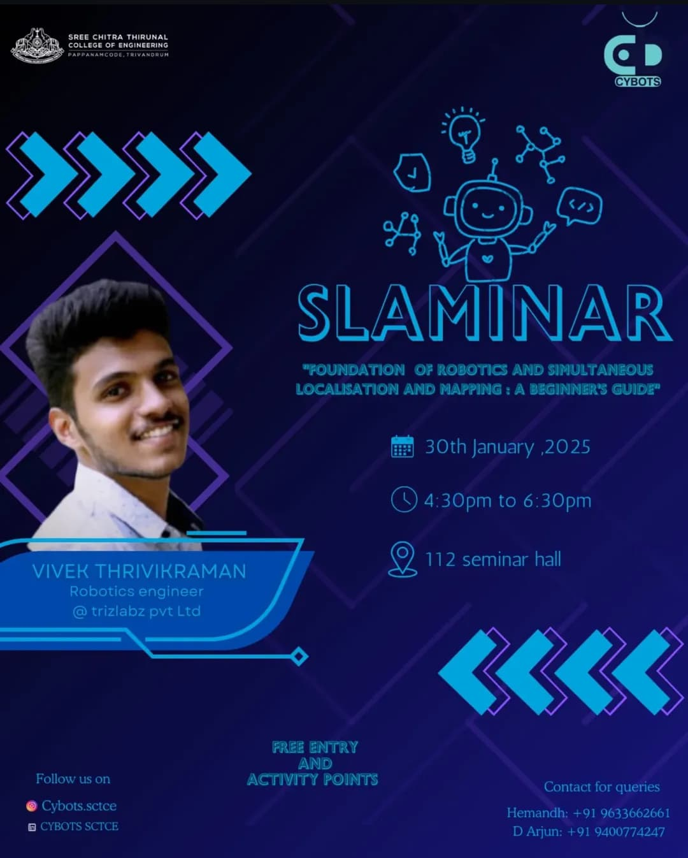

The session featured Mr. Vivek Thrivikraman, a Robotics Engineer at Trizlabz and an esteemed alumnus of SCTCE, as the speaker. With hands-on experience in autonomous systems and a deep understanding of Simultaneous Localization and Mapping (SLAM), Mr. Vivek provided attendees with a comprehensive overview of the fundamentals of robotics, the principles of SLAM, and its real-world applications

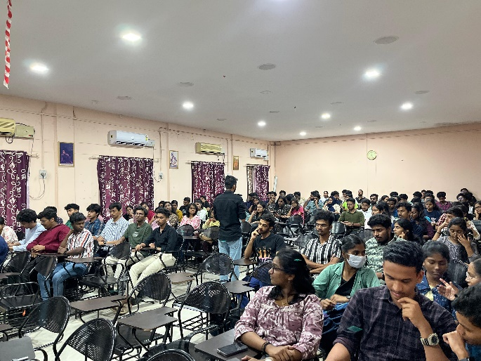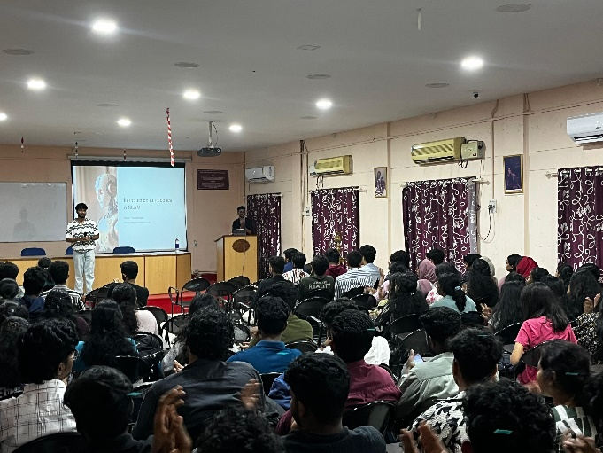
The seminar began with an engaging overview of robotics and the fundamentals of SLAM, explaining how autonomous systems map and navigate unfamiliar spaces without GPS. Complex concepts were simplified through examples, videos, and demos, keeping the audience actively involved.
Students from various departments participated enthusiastically, with a lively Q&A session covering topics like SLAM in drones and ROS-based projects. The session not only deepened attendees’ technical understanding but also strengthened alumni-student connections, reinforcing Cybots’ role in fostering a vibrant robotics community at SCTCE.

- AeroBotix – The Drone Workshop

As part of Cybots' mission to provide hands-on exposure and practical skills in emerging technologies, we conducted AeroBotix, a comprehensive drone engineering workshop, on March 15, 2025. This workshop was designed to introduce students to the fundamentals of Unmanned Aerial Vehicles (UAVs) through interactive sessions and real-time demonstrations.

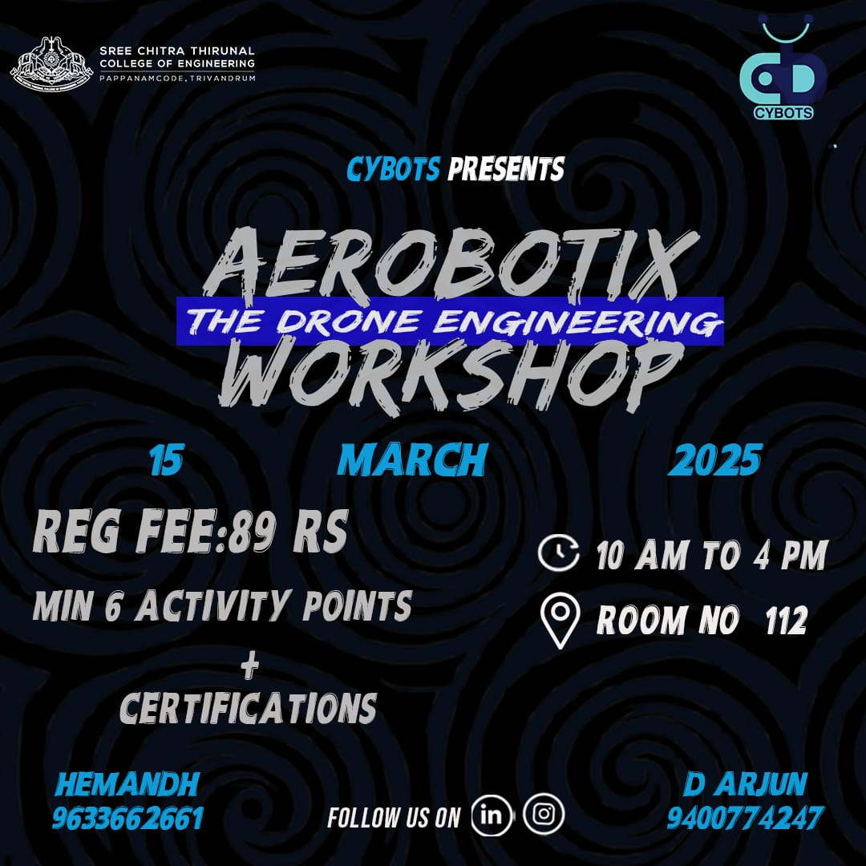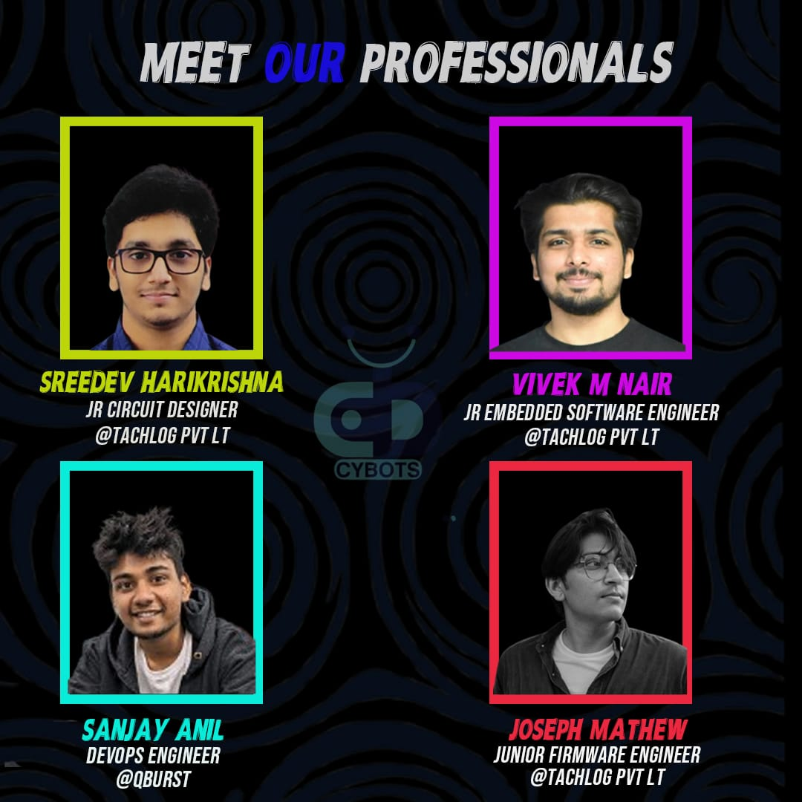

The workshop was led by four young professionals working in the tech industry:
- Sreedev Harikrishna – Jr Circuit Designer at Tachlog Pvt Ltd
- Vivek M Nair – Jr Embedded Software Engineer at Tachlog Pvt Ltd
- Joseph Mathew – Junior Firmware Engineer at Tachlog Pvt Ltd
- Sanjay Anil – DevOps Engineer at QBurst

The speakers brought in-depth technical insights and practical experience, offering students a closer look at drone systems, components, and operations. The sessions covered the working principles of F450 drones, Arduino-based simulations, RF communication, basic aerodynamics, and safety protocols in UAV design.

The highlight of the workshop was a drone flying demonstration, where participants got to observe and understand real-time drone flight control and dynamics. Students also had the opportunity to interact with the experts and clarify their doubts regarding drone-based projects and applications.

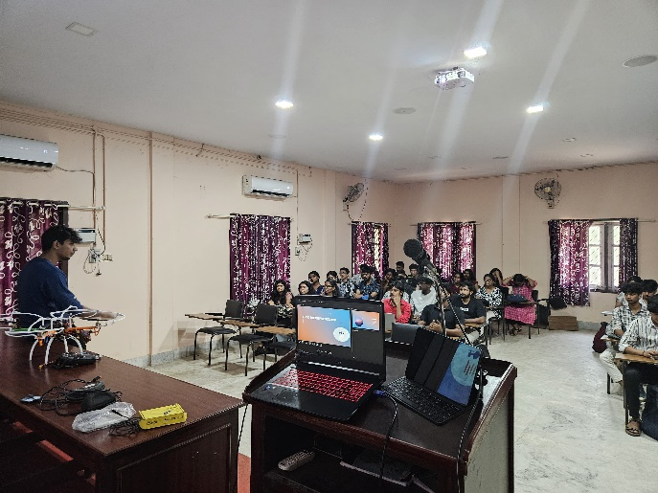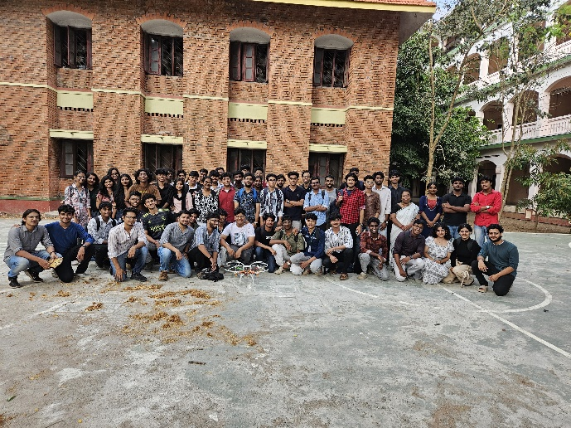
The event saw active participation from students across departments, many of whom expressed keen interest in pursuing drone-related innovations. The success of AeroBotix reflected the growing enthusiasm for aerial robotics and marked another step forward in Cybots' efforts to make robotics education engaging and accessible at SCTCE.

"With every bot built and every idea shared, Cybots continues to push boundaries and inspire innovation. As we move forward, we aim to keep learning, building, and dreaming — together as a community of creators. Here’s to another year of robotics, growth, and impact."

